- BACKWARD CHAINING
AIM
To develop a Prolog program that implements backward chaining by starting with a goal and working backward through rules to verify whether the goal can be proved from known facts.
OBJECTIVE
- To understand the concept of backward chaining in Artificial Intelligence.
- To represent knowledge using facts and rules in Prolog.
- To start with a goal and search for supporting facts.
- To execute Prolog queries and verify the conclusion.
ALGORITHM
- Start the program.
- Define the initial facts.
- Define the rules required to derive conclusions.
- Select a goal to be proved.
- Check whether the goal is directly available as a fact.
- If not, find a rule whose conclusion matches the goal.
- Check the conditions of that rule recursively.
- If all conditions are satisfied, prove the goal.
- Display the result.
- Stop.

FLOWCHART
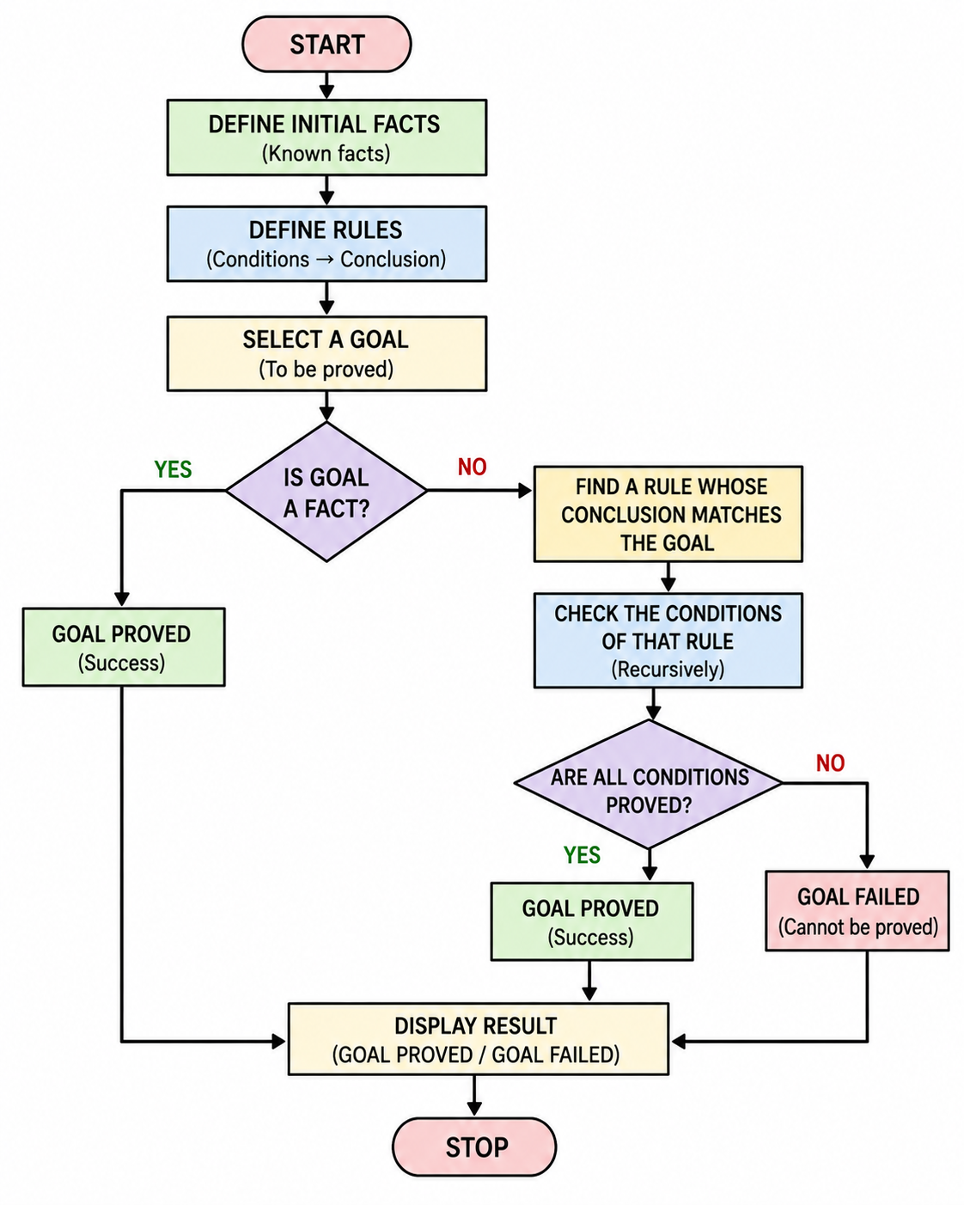
CODE
% BACKWARD CHAINING PROGRAM
% INITIAL FACTS
fact(fever).
fact(cough).
fact(body_pain).
% RULES
rule(flu) :-
fact(fever),
fact(cough),
fact(body_pain).
rule(infection) :-
fact(cough),
fact(body_pain).
rule(serious_flu) :-
rule(flu),
rule(infection).
% BACKWARD CHAINING
backward_chain(Goal) :-
rule(Goal).
backward_chain(Goal) :-
fact(Goal).
% START PROGRAM
start(Goal) :-
backward_chain(Goal),
write('Goal proved: '),
write(Goal),
nl.
start(Goal) :-
\+ backward_chain(Goal),
write('Goal cannot be proved: '),
write(Goal),
nl.

OUTPUT

RESULT
Thus, the backward chaining program was successfully implemented in Prolog. The program starts with a goal and works backward through the available rules and facts to determine whether the goal can be proved.

